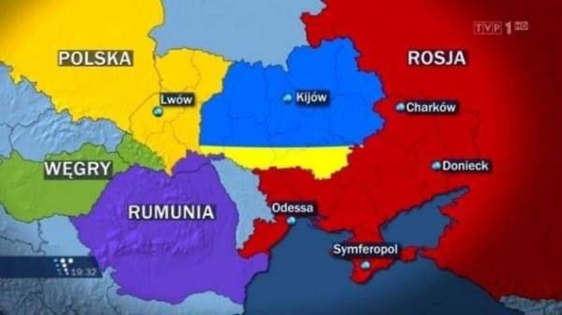

“New Map of Ukraine was Shown on Polish TV” according to Russian news.

